Lab Exercise - 20 App Deployment Using ECS And ECR
Name: Aryan
SAP ID: 500120565
Batch: 2 DevOps
Step 1: Create ECR Repository
- Go to AWS Console
- Search Elastic Container Registry (ECR)
- Click Create Repository
- Give name (example: my-web-app) ● Click Create

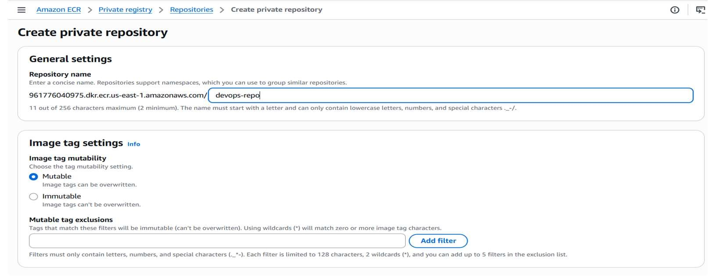

Step 2: Configure aws
Create access key
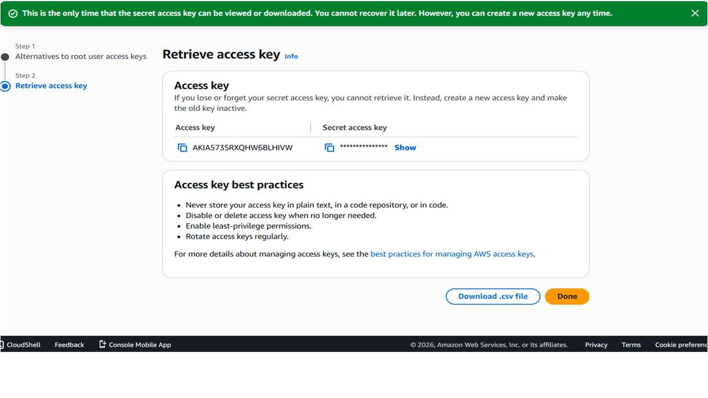
Step 3: Authenticate Docker to ECR Run this :
aws ecr get-login-password --region us-east-1 | docker login --username AWS -password-stdin 961776040975.dkr.ecr.us-east-1.amazonaws.com

Step 4: Build Docker Image Run this :
docker build -t devops-repo .
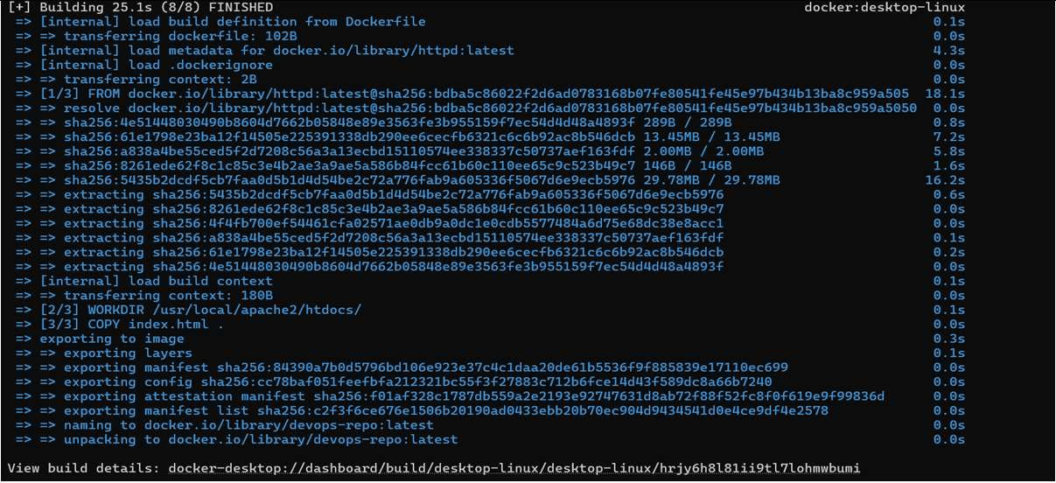

Step 5: Tag Docker Image Run this :
docker tag devops-repo:latest 961776040975.dkr.ecr.us-east-
1.amazonaws.com/devops-repo:latest

Step 6 : Push Docker Image Run this :
docker push 961776040975.dkr.ecr.us-east-1.amazonaws.com/devops-repo:latest

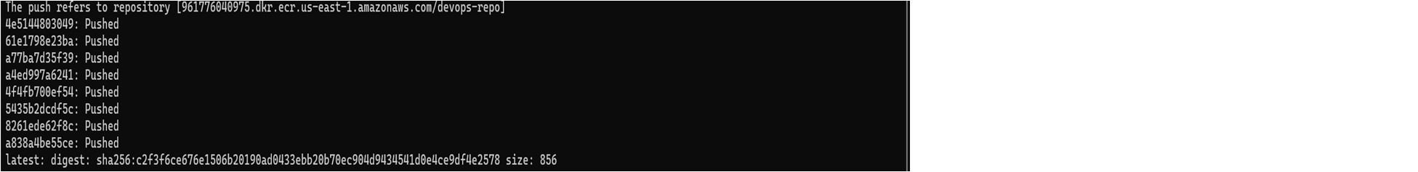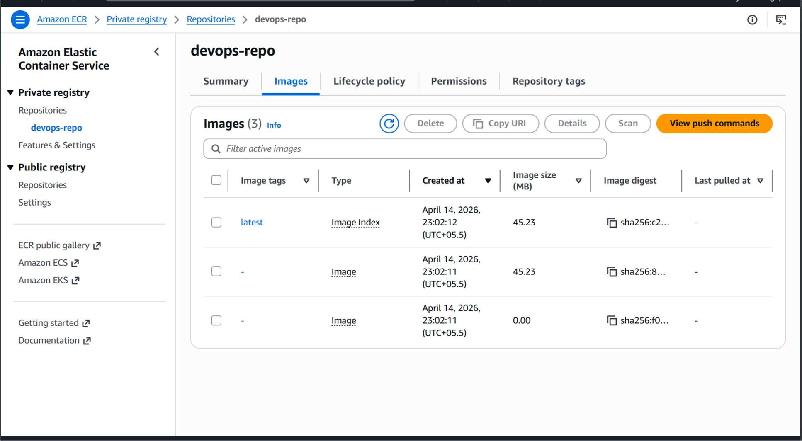

Step 7: Create Cluster
- Go to ECS
- Click Create Cluster
- Select Fargate (Serverless)
- Cluster Name: devops-cluster-new
- Click Create

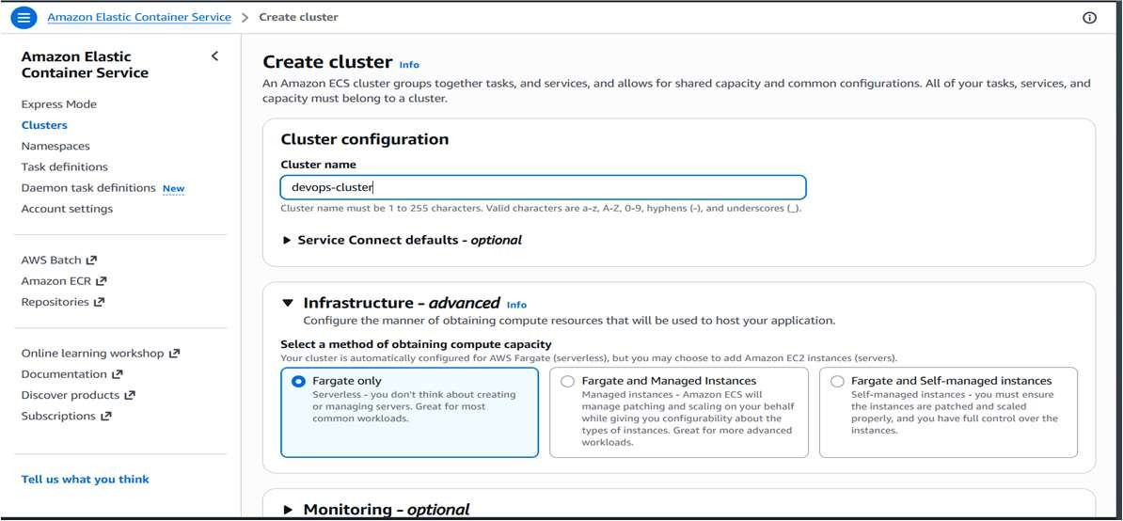

Step 8: Create Task Definition
- Launch Type → Fargate
- Container Image → Paste ECR URI

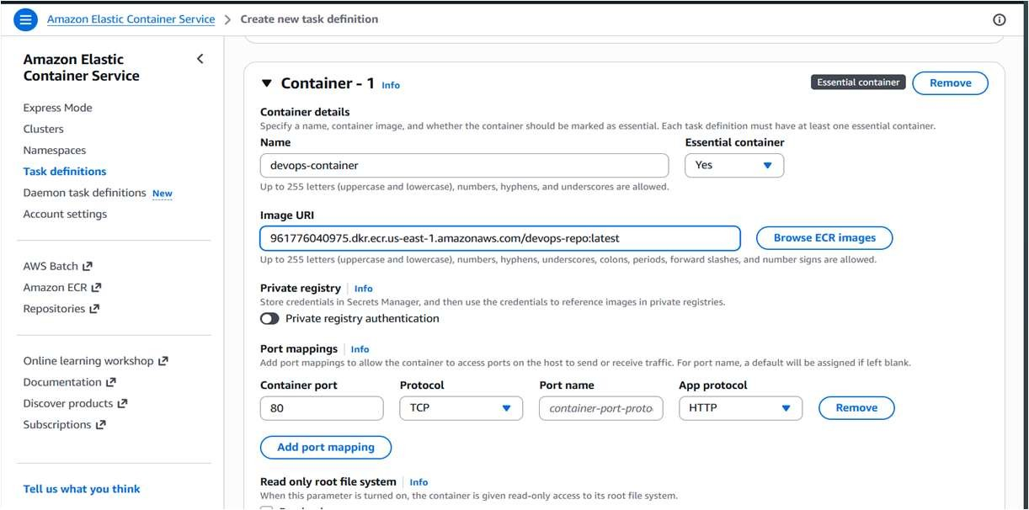
Step 9: Create Service
- Go to Cluster
- Click Create Service

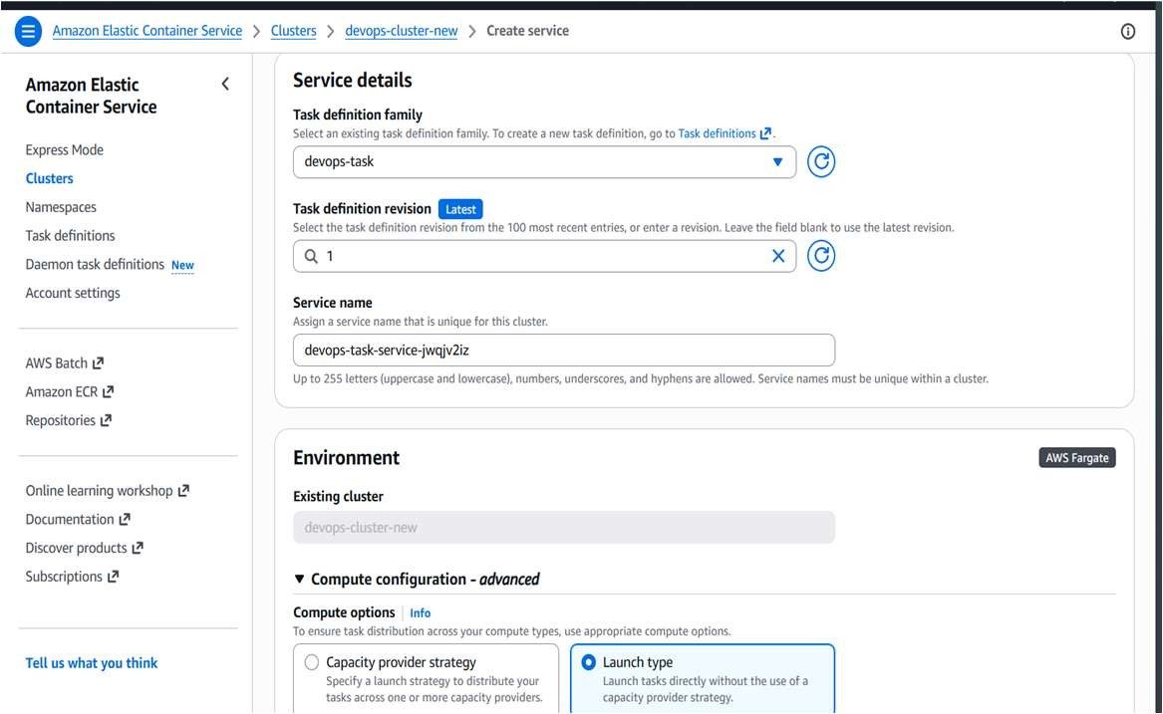
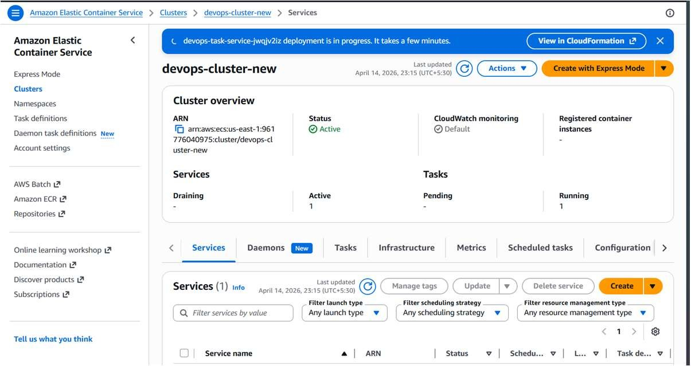
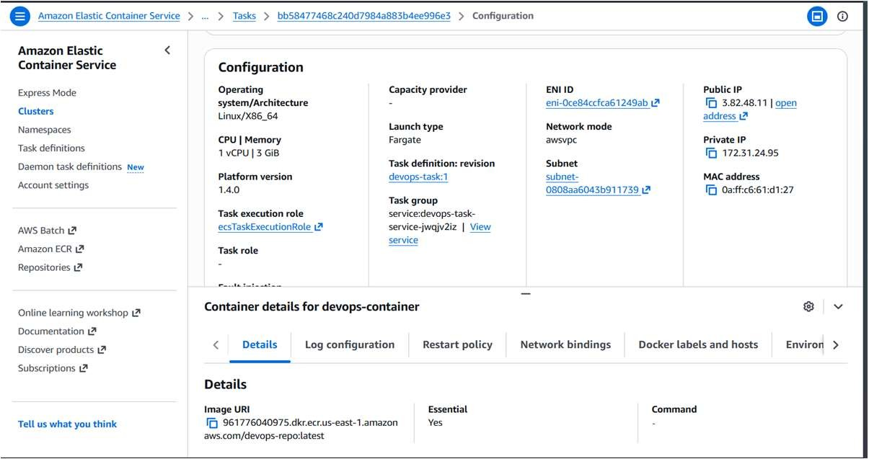
Step 10: Turn on all traffic in security broke
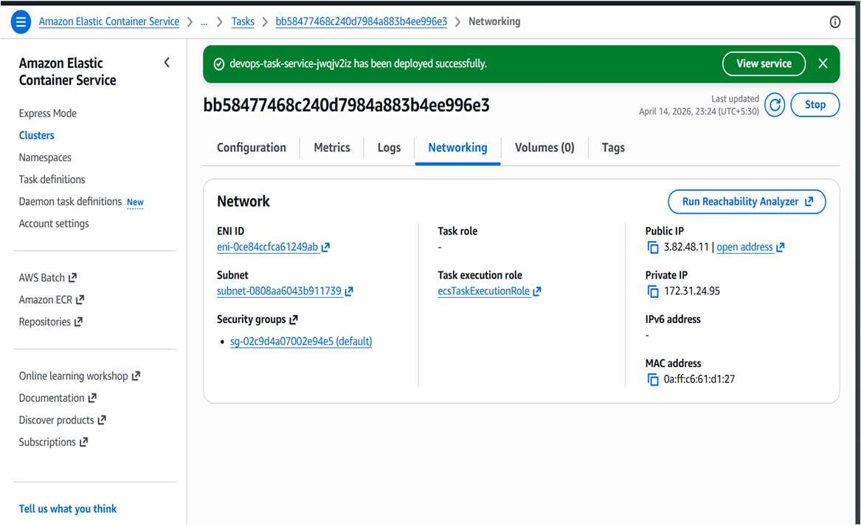
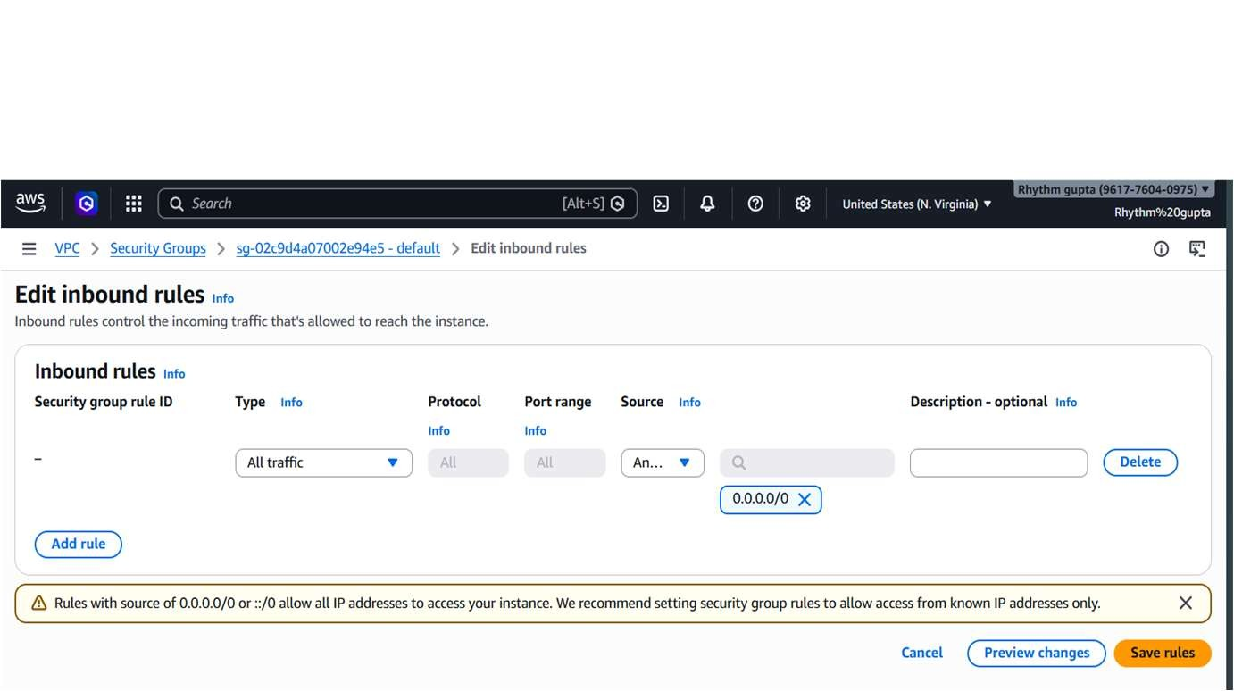
Step 11 : Verify Deployment
- Go to Load Balancer
- Copy DNS Name
- Paste in Browser

